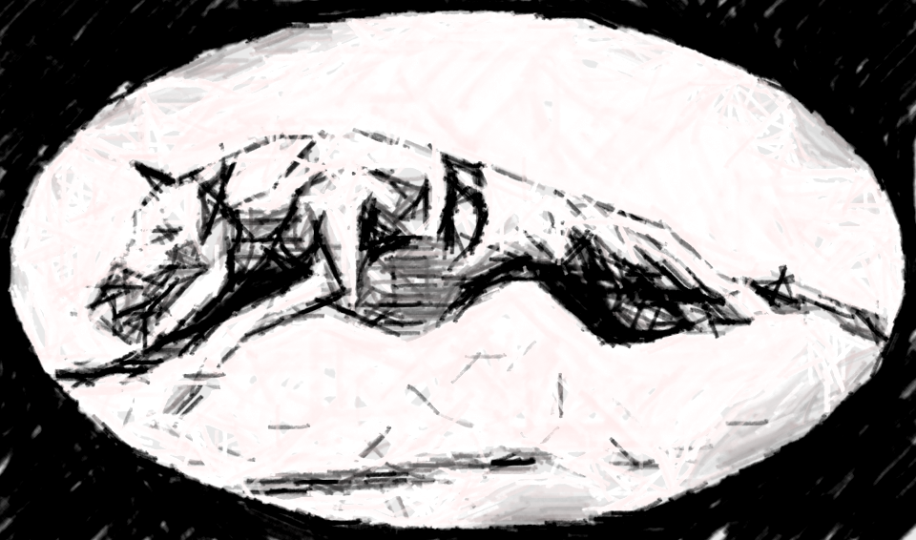
GEORGIA RAG RACING
December 17-18, 2016 - CWA Straight Racing
One Day Farms - Hull, GA 30646
PRE-Entries must be received by Wednesday, December 14th, 2016

INSPECTION
*** INSPECTION TIMES - 8:00 A.M. Saturday & Sunday ***

Conformation Judges
Saturday Judge: Carol Zienert / Wildbriar Whippets / Sunday Judge: Christine Heath / Christeva Whippets

BEST OF THE BEST drawing on Saturday and Sunday.
***************1 Winner will be drawn each day and receive a ***************
25x34” PVC Cot / made by Lisa Saunders
This is where we put winners name in a hat and draw at random. Those that qualify are any dogs who received ARX or NARX points that day, the meet winner, best combined winner, conformation placements, the top winners of each grade and the Turtle winner.

All dogs must be pre-registered with CWA to enter.
Dogs must be box trained and proofed before being allowed to enter.
Trophy donations are always needed for the trophy table! Thanks!

ENTRY FEES:
- GRR members: $15 first dog, $10 each additional
- Non-Members: $20 first dog, $12 each additional,
- Day of race entries $25
(Checks payable to GRR or PAYPAL to georgiaragracing@gmail.com)
(Please add $1.50 to your entries if paying by paypal)
Mail entry forms and fees to
Mail to Georgia Rag Racing / Chris Durance-Watkins, Race Secretary
1488 Crabapple Hollow Rd, Hull, GA 30646-2800 or email georgiaragracing@gmail.com
If emailing entries please include registered name of dog with titles, call name,
racing grade and CWA number.
Payment must be made to the race secretary prior to your dog being inspected

OR
You can also enter ONLINE at: http://www.georgiaragracing.com/grr_entry.html

Practice proofing and practice for new dogs wanting to run this weekend will be
held Friday afternoon as time permits.
This is no guarantee that your dog will get to practice nor is it a guarantee that they will run.

AREA HOTELS THAT ACCEPT DOGS (all are off I-85 Commerce, exit 149)
Red Roof 30747 Highway 441 S Commerce GA30529 (706) 335-5783
Howard Johnson, 148 Eisenhower Dr., Commerce, GA 30529 (706)335-5581 $10 pet fee
Comfort Suites, 30490 Highway 441 Commerce, GA 30529 (706)336-0000 $25 fee
Best Western 157 Eisenhower Dr., Commerce, GA 30529 (706)335-3640 $10 fee
Quality Inn, 165 Eisenhower Rd., Commerce, GA 30529 (706)335-9001 $10 fee
Super 8, 152 Eisenhower Rd., Commerce, GA 30529 (706)336-8008 $10 fee
Motel 6, 128 Frontage Rd., Commerce, GA 30529 (706) 335-5561

DIRECTIONS
One Day Farms - Field is located across the road from 712 Sawdust Rd, Hull GA 30646

From I-85 Southbound and Northbound take exit 149 (Commerce exit). At the end of the ramp turn left if coming southbound and right if coming northbound onto Route 441-15 South. Follow
Route 441 South for approx. 5 ½ miles. Look for railroad crossing signs. When you see the railroad crossing signs, get into the l
Left lane. At the light, turn left onto Route 334 East (landmark = Ingles grocery store). Follow Route 334 East for approx. 6 miles. You will pass a small farm equipment store (Vermeer Equipment) on the left. Approximately ¾ mile past this store, turn left on Seagraves Mill Road. Follow Seagraves Mill Road for 3 ½ miles to the stop sign (crossroad is Nowhere Road/Sawdust Rd). Take Sawdust Rd.
Proceed ½ mile and turn left onto the field.

Please bring your own shade and water to the field

Practice will be held Sat. after the Conformation match is finished, weather, daylight and machinery dependent.
All breeds eligible to practice. Preference will be given to club members / whippets

LUNCH
Saturday – TBA Sunday – TBA

