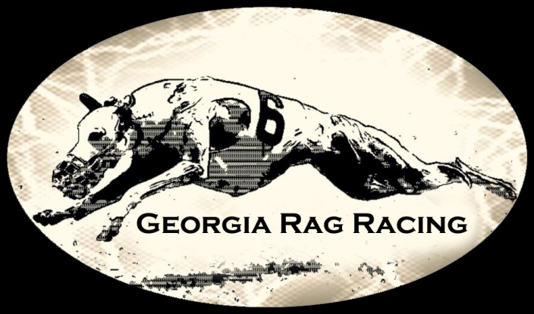
February 10th & 11th , 2018
CWA Straight Racing / One Day Farms - Hull, GA 30646

INSPECTION
*** INSPECTION TIMES - 8:00 A.M. Saturday & Sunday ***
Conformation Judges
Saturday – Carol Cox / Rhapsody Whippets
Sunday – Margaret Norkett / Kenmar Whippets

We will be running a 175 yard track for adults both days!
ENTRY FEES:
- GRR members: $15 first dog, $10 each additional
- Non-Members: $20 first dog, $12 each additional,
- Day of race entries $25
PRE-Entries must be received by Wednesday, February 7th, 2018

All dogs must be pre-registered with CWA to enter. Dogs must be box trained before being allowed to enter.
This is for the safety of the dog and for the dogs running with them.
Practice proofing and practice for new dogs wanting to run this weekend will be held Friday afternoon at 2pm.
There is no guarantee that your dog will get to practice nor is it a guarantee that they will run.

Mail entry forms and fees to
Chris Durance-Watkins, Race Secretary / Georgia Rag Racing
1488 Crabapple Hollow Rd, Hull, GA 30646-2800
or email georgiaragracing@gmail.com
You can also enter ONLINE at: http://www.georgiaragracing.com/grr_entry.html
You can write checks payable to GRR or Paypal your entry money to georgiaragracing@gmail.com
(please add $1.50 to your entries if paying by paypal)
Email entries are also accepted.
Mail to: georgiaragracing@gmail.com Include the following information :
Registered name of dog with titles, call name, racing grade or FTE, and CWA
number and what days you plan to enter.
Trophy donations are always needed for the trophy table! Thanks!

AREA HOTELS THAT ACCEPT DOGS (all are off I-85 Commerce, exit 149)
*Red Roof 30747 Highway 441 S Commerce GA30529 (706) 335-5783 (most people stay here)
Howard Johnson, 148 Eisenhower Dr., Commerce, GA 30529 (706)335-5581 $10 pet fee
Comfort Suites, 30490 Highway 441 Commerce, GA 30529 (706)336-0000 $25 fee
Best Western 157 Eisenhower Dr., Commerce, GA 30529 (706)335-3640 $10 fee
Quality Inn, 165 Eisenhower Rd., Commerce, GA 30529 (706)335-9001 $10 fee
Super 8, 152 Eisenhower Rd., Commerce, GA 30529 (706)336-8008 $10 fee
Motel 6, 128 Frontage Rd., Commerce, GA 30529 (706) 335-5561
*most whippet people stay
DIRECTIONS
One Day Farms - Field is located across the road from 712 Sawdust Rd, Hull GA 30646
From I-85 Southbound and Northbound take exit 149 (Commerce exit). At the end of the ramp turn left if coming southbound and right if coming northbound onto Route 441-15 South. Follow
Route 441 South for approx. 5 ½ miles. Look for railroad crossing signs. When you see the railroad crossing signs, get into the l
Left lane. At the light, turn left onto Route 334 East (landmark = Ingles grocery store). Follow Route 334 East for approx. 6 miles. You will pass a small farm equipment store (Vermeer Equipment) on the left. Approximately ¾ mile past this store, turn left on Seagraves Mill Road. Follow Seagraves Mill Road for 3 ½ miles to the stop sign (crossroad is Nowhere Road/Sawdust Rd). Take Sawdust Rd.
Proceed ½ mile and turn left onto the field.

Please bring your own shade and water to the field
Practice will be held Sat. after the conformation match is finished, weather, daylight and machinery dependent. All breeds eligible to practice. Preference will be given to club members & whippets

Meal each day - $5 includes a drink
BREAKFAST – Coffee, pigs in a blanket and maybe biscuits or breakfast burritos, or sausage gravy and biscuits
LUNCH Saturday- Crazy Dave's Chili & Sandy's Soup of choice
LUNCH Sunday - Chicken fingers donated by Zaxby's Chicken! Thank you Dawn for getting this together!
Please check out our Facebook page to see what sides we will need volunteers to bring.
